SciCast: Collective Forecasting of Innovation
1
Charles Twardy, Robin Hanson, Kathryn Laskey, Tod S. Levitt George Mason University
BRANDON GOLDFEDDER, Gold Brand Software LLC, Adam Siegel, Inkling Markets
BRUCE D’AMBROSIO, Tuuyi, Inc., DANIEL MAXWELL, KaDSci LLC

INTRODUCTION
Forecasting technological innovation is of vital interest to business, government, and the public at large. Technological innovation has driven fundamental changes to our way of life. Improved accuracy in predictions would provide major competitive advantage to businesses, help governments to choose investments wisely, and enable citizens to make more informed personal and political choices.

Most forecasts are based on the judgments of a handful of experts, an approach well known to be less accurate than even simple statistical models [Dawes, Faust, and Meehl 1989]. Recent research suggests that forecasting accuracy can be improved through application of the “wisdom of crowds.” [Surowiecki 2005] The most common aggregation method is a simple unweighted average. This method has been hard to beat despite its theoretical sub-optimality. Evidence is mounting however, that prediction markets [Chen and Pennock 2011] outperform not only the judgments of individual experts, but also simple averages. For example, in a two-year test on geopolitical questions, the DAGGRE prediction market performed 40% better than the simple average [Twardy and Laskey 2012, Twardy and Laskey 2013]

SciCast, launched in November 2013, is the largest and most advanced science and technology prediction market in the world. SciCast is a community-driven initiative that allows scientists, technologists, and technology watchers around the globe to forecast science and technology trends, and to contribute forecasting questions. SciCast participants can move probabilities of a question up or down in accordance with their beliefs. When the answer becomes known, participants will win or lose points according to whether they moved the probability in the right direction. In a friendly competition, participants vie for position on the leaderboard and engage in animated discussions of future technological trends. Participants can also propose questions to be included in the market.

For example, someone posed the question, Will Amazon deliver its first package using an unmanned aerial vehicle by Dec. 31, 2017? As of this writing, SciCast estimates the chance at about 57%. A participant who thinks that is too low can move the probability higher either by choosing a probability bin or by using a slider to set a new probability directly (see Figure 1). Through the inputs of many users, SciCast continually updates its forecasts over time (see Figure 2). Forecasters can update their estimates at any time, for example after the FAA releases their new guidelines for drones. The continually updated and reshaped information helps both the public and private sectors better monitor developments in a variety of industries. SciCast is a real-time indicator of what participants think is going to happen in the future.

Exploiting relationships among questions
Forecasters discuss the questions, and that discussion can lead to new related questions. For example, in response to the Amazon package delivery question, a forecaster suggested that this technology is likely to first be used in a mid-size town with fewer obstructions or local regulatory issues. Another replied that Amazon is more likely to use robots to deliver packages within a short radius of a conventional delivery vehicle, while a third offered information about a Federal Aviation Administration report related to the subject. Any forecaster could then write a question about upcoming FAA rulings, and link that question to the Amazon drones question.
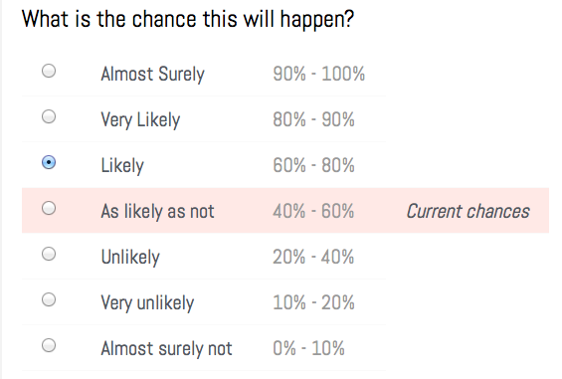 | 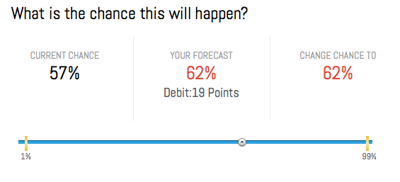
Fig. 1. SciCast participants can enter forecasts either by using a survey-style interface to select a probability range or by moving a slider to change the probability to a new value. The former method moves the probability a small amount in the direction of their expressed belief. The latter method allows them to see how many points they are putting at risk to make the change.
Once questions have been linked, forecasters can make conditional forecasts. For example, because crop production has been linked to honeybee populations, a participant who has made a forecast about the percentage of honey bee colonies lost in the US during the 2013-14 winter will be offered the opportunity to forecast U.S. production of crops conditional the percentage of honey bee colonies lost (see Figure 3). Through participants’ forecasts, SciCast will learn the strength of the relationship and will adjust its forecasts accordingly.

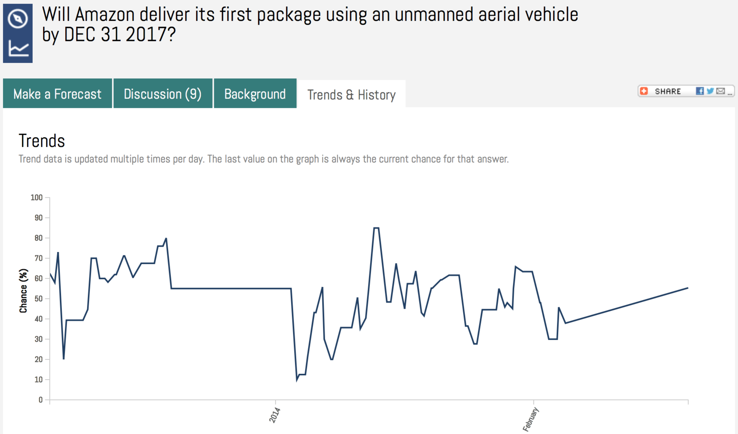
Fig. 2. SciCast users can view how the probabilities of a question have changed over time.
A prediction market that allows questions to be linked is called a combinatorial prediction market. SciCast is the first general purpose combinatorial predication market. The SciCast combinatorial market uses a generalization of algorithms developed for updating probabilities in Bayesian networks. The result is an efficient method to update probabilities when users make forecasts and at the same time compute the impact of participants’ trades on their assets [Sun et al. 2012]..
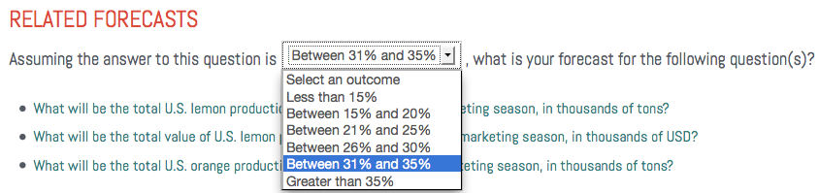
Fig. 3. SciCast allows users to condition their forecasts on the outcomes of related questions.

a platform for research
In addition to making forecasts, participating in discussions, and authoring questions, SciCast users can access forecast data from the SciCast data mart for their own research.

SciCast partner organizations include the American Association for the Advancement of Science (AAAS), the Institute of Electrical and Electronics Engineers (IEEE), the Information Systems Audit and Control Association, Inc. (ISACA), the American Medical Informatics Association (AMIA), and TechCast. By posing questions to SciCast, partner organizations are able to bring the SciCast technology to bear on questions of interest to their organizations.

The SciCast research team is conducting several research studies to help us learn how to use the wisdom of crowds to improve forecasts. These include studies comparing SciCast with quantitative forecasting methods, studies to assess the benefits of linking questions, and studies examining the effect of including computerized traders in the SciCast prediction market. We are collaborating with researchers at DRDC Canada, and the TechCast project at George Washington University. The SciCast team is led by George Mason University and includes Inkling Markets, Gold Brand Software, Tuuyi, and KaDSci. Through early 2014 we have been developing and using the UnBBayes software. [Matsumoto et al. 2011].

Conclusion
SciCast aims to increase the accuracy of science and technology forecasts by tapping the collective intelligence of thousands of users around the world. Users spend points to make forecasts, and gain more than they spend if they turn out to be right. Better forecasters gain more points and therefore more influence, improving system accuracy. SciCast allows forecasters to link questions and make conditional edits: almond yield can depend on honeybee collapse, or photovoltaic price-performance on the progress of multijunction arrays. At any time, SciCast provides a real-time assessment of the probability of any of its questions, given the information currently available to its participants.

SciCast topics include: agriculture, biology and medicine, chemistry, computational sciences, energy, engineered technologies, global change, information systems, mathematics, physics, science and technology business, social sciences, space sciences and transportation. Scientists, statisticians, entrepreneurs, policymakers, technical traders and futurists of all stripes are encouraged to improve our forecasts, link questions, and pose new questions. SciCast is accessible at https://scicast.org.
ACKNOWLEDGEMENTS
This research was supported by the Intelligence Advanced Research Projects Activity (IARPA) via Department of Interior National Business Center contract number D11PC20062. The U.S. Government is authorized to reproduce and distribute reprints for Governmental purposes notwithstanding any copyright annotation thereon. Disclaimer: The views and conclusions contained herein are those of the authors and should not be interpreted as necessarily representing the official policies or endorsements, either expressed or implied, of IARPA, DoI/NBC, or the U.S. Government.
REFERENCES
Yiling Chen and David M Pennock. 2011. “Designing Markets for Prediction.” AI Magazine 31 (4) (January 13): 42–52. doi:10.1609/aimag.v31i4.2313. http://www.aaai.org/ojs/index.php/aimagazine/article/view/2313.
Robyn Dawes, David Faust, and Paul Meehl. 1989. “Clinical Versus Actuarial Judgment.” Science 243 (4899): 1668–74. http://www.sciencemag.org/cgi/content/abstract/243/4899/1668.
Shou Matsumoto, Rommel N. Carvalho, Marcelo Ladeira, Paulo Cesar G. Costa, Laecio Santos, Danilo Silva,, Michael Onishi, and Emerson Machado. 2011. “UnBBAyes: A Java Farmework for Probabilistic Models in AI.” In Java in Academia and Research, edited by Ke Cai, Single:Chapter 9, 34pp. Annerley, Australia: iConcept Press. http://www.iconceptpress.com/www/site/download.paper.php?paperID=101214103948.
Wei Sun, Robin Hanson, Kathryn Laskey, and Charles Twardy. 2012. “Probability and Asset Updating Using Bayesian Networks for Combinatorial Prediction Markets.” In Proceedings of the 28th Conference on Uncertainty in Artificial Intelligence (UAI-2012). Catalina, CA: AUAI Press. http://mason.gmu.edu/~wsun/publications/uai2012.htm.
James Surowiecki. 2005. The Wisdom of Crowds. Reprint. Anchor.
Charles R. Twardy and Kathryn Laskey, eds. 2012. “DAGGRE Annual Report 2012.”
Charles R. Twardy and Kathryn Laskey, eds. 2013. “DAGGRE Annual Report 2013.”

